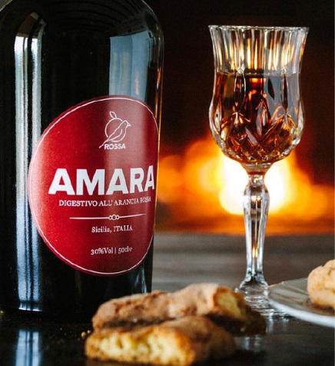

AMARAMIXOLOGY

AMARATONIC: 1/3 AMARA, 2/3 Tonic Water, Ice and Orange slice (fresh mint or red pepper)

AMARAGINGER : 1/3 AMARA, 2/3 Prosecco, Ice, Ginger and Lime

AMARACANO : 1/3 AMARA, 1/3 Campari, 1/* Soda, Ice and Orange slice
AMARITO : the Orginal Mojito with AMARA

AMARASUMMER : ½ AMARA, ½ Club Soda (Lemon Soda, Sprite), Ice, fresh mint and fresh red pepper

AMARACOOLER : 1/3 AMARA, 1/3 Grenadine syrup, 1/3 Soda and lemon juice, Ice

AMARASPRITZ : ¼ AMARA, ¼ Aperol, ¼ Prosecco, ¼ Soda, Ice and Orange slice

